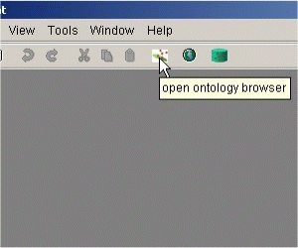
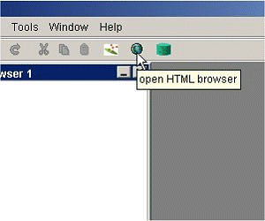
Step 1: Open Ontology-Browser

Open the Ontology-Browser, if not already open.

Step 2: Open Web Browser
Open the Web-Browser, if not already open.
Step 3: Load HTML document
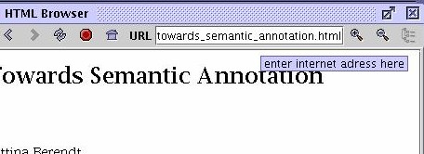
Load an HTML document by entering the URL of the web document that would you like to annotate. OntoMat-Annotizer will use the URL of your document as the namespace of your annotation. If you don't like that, you can change the namespace with "Tools->HTML Browser->change document namespace". You can check the namespace of your document on the bottom of your browser panel.

Step 4: Open OWL Ontology
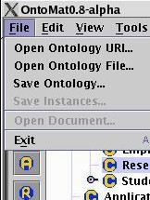
Open the OWL ontology, via URI or as file, e.g. the ISWC ontology:
http://annotation.semanticweb.org/ontologies/iswc.owl. Open the URI dialog and click on the "load" button.
Step 5: Browse Ontology
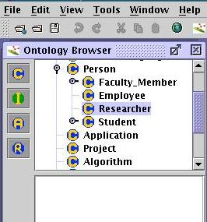
Browse through the Ontoloy to get familiar with it

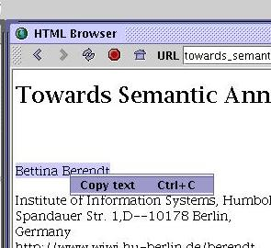
Step 6: Select text
Select the text fragment which you like to use for your annotation.

Step 7: Create Instance
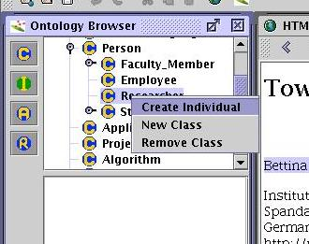
Select in the ontology the class where the text fragment fits in. Drag the selected text on the appropriate class (drag`n drop). The annotation gets created and thus the text fragment will be shown as an instance of the selected class in the ontology at the ontology browser.

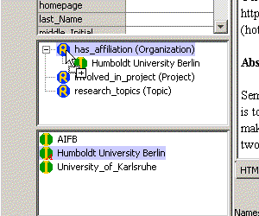

Step 8: Create Attributes
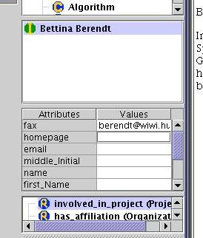
To each created instance, literal attributes can be assigned. The choice of the predefined attributes depends on the class the instance belongs to, e.g. the class "Researcher" has the attributes name, address, email, and telephone number. The attributes can be assigned to the instance by selecting the appropriate text fragment of the web document and copy it to the related property field (drag'n drop).
Step 9: Create Relations
Furthermore, the relationships between the created instances can be set, e.g. the Researcher "Bettina Berndt" is affiliated to the "Humbolt University". OntoMat-Annotizer preselects class instances according to the range restrictions of the chosen relation, e.g. the "has_affilation" of a Person must be an Organizations. Therefore only these are offered as potential fillers to the "has_affilation" relation. Choose the appropriate instance and drag it to the relation (drag'n drop). !!Due to implementation reasons, this is not consistent with right mouse click for the other steps!!.

Step 10: Control and Edit you Annotation manually.
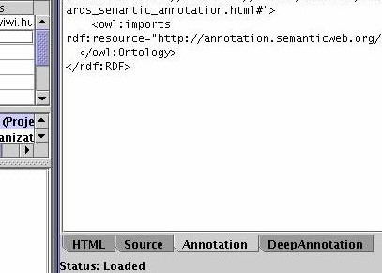
With the annotation tab you can switch to the textual representation of your annotation. You can do here some changes manually, but take care of consistency.

Step 11: Save HTML table page.
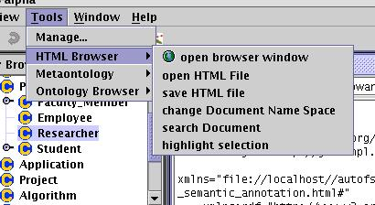
Finally save your annotated HTML table page.

