http://www.smarttech.com/Home%20Page/Solutions/Education%20Solutions?WT.ac=HPBtn1_Ed_072610

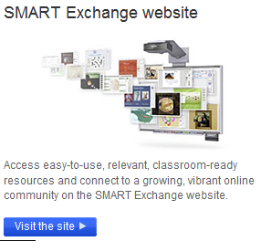
http://exchange.smarttech.com/#tab=0
scienze sociali http://exchange.smarttech.com/search.html?sbj=scisoc

http://www.edidasko.org/repository-lo.html

