http://www.youtube.com/watch?v=Su89JQMMQ-E&feature=related

Microsoft Office | MSWord, MSExcel, MSPowerPoint
Applicazioni grafiche | CorelDraw, Microsoft Imaging, Corel Grafgo, MSPaint
Applicazioni per Presentazioni | MSPowerPoint, Corel Presentations, Microsoft NetMeeting
Altre applicazioni | AutoCad, VoloView Express, AutoVue professional, Microsoft Windows Journal, Adobe Acrobat

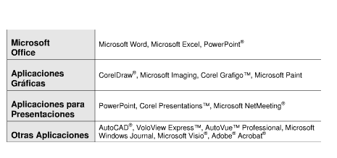

https://strathhavencff.wikispaces.com/-DIY+SMARTBoard
http://education.smarttech.com/ste/en-US/Ed+Resource/

