risorse
BANCA RISORSE PER LIM
http://www.think-bank.com/iwb/
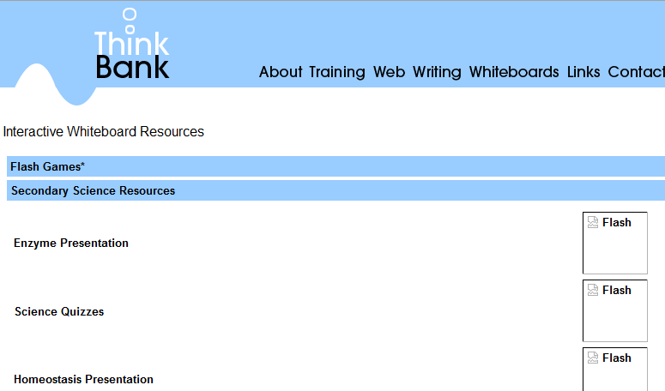
http://www.whiteboardblog.co.uk/2009/07/20-interactive-whiteboard-resources-for-teachers/
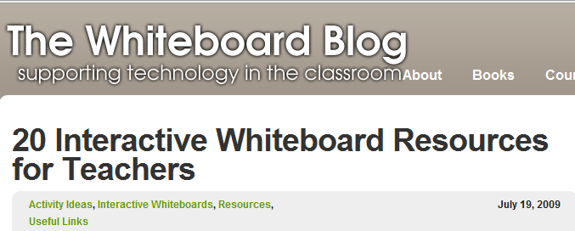
http://www.whiteboardblog.co.uk/guides/
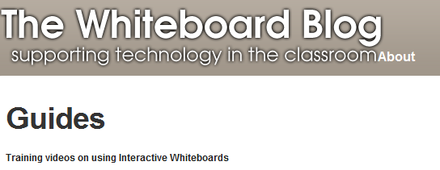
http://www.vimeo.com/1441211
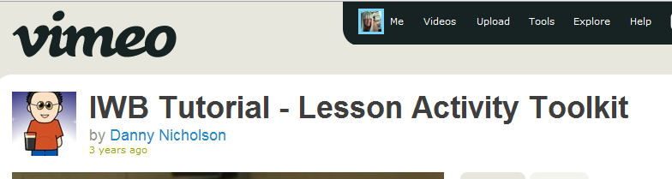
PER SALVARE VIDEO YOUTUBE IN SWF
http://www.scribd.com/doc/22598482/How-to-Insert-a-YouTube-Video-Into-Smart-Notebook

http://www.britishmuseum.org/

http://www.mesopotamia.co.uk/menu.html

scienze
http://www.thelayeredearth.com/teachable.html

http://www.windows2universe.org/earth/earth.html
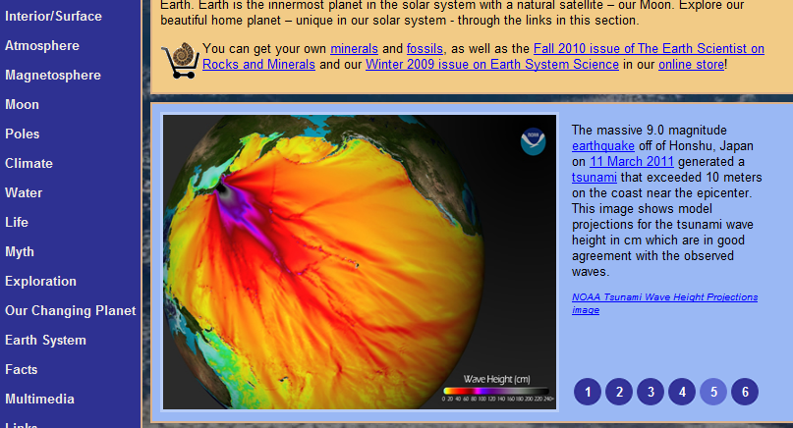
http://www.windows2universe.org/mythology/worldmap_new.html
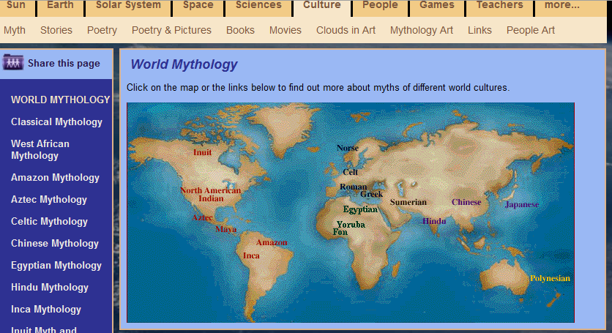

http://www.windows2universe.org/teacher_resources/main/teacher_resources.html
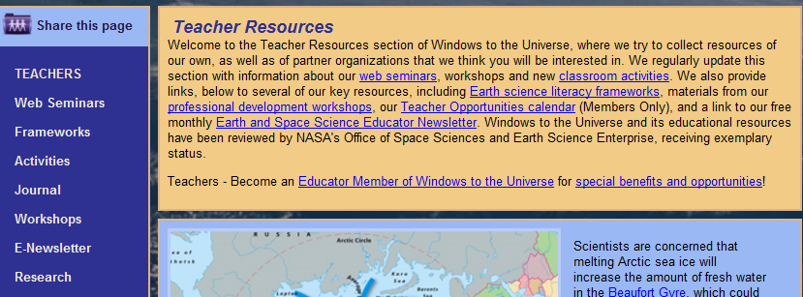
http://www.quia.com/pages/ohostetter/teacher2teacher
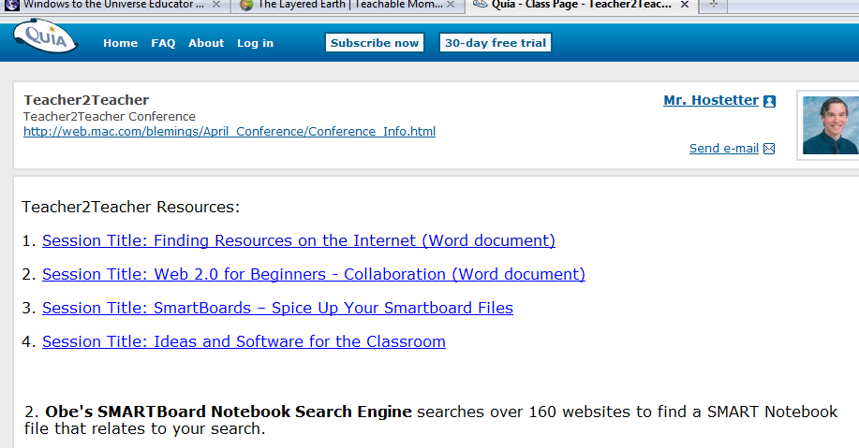
MOTORE DI RICERCA SMARTNOTEBOOK
http://www.google.com/cse/home?cx=016810805021913517955:or31dm2nwok
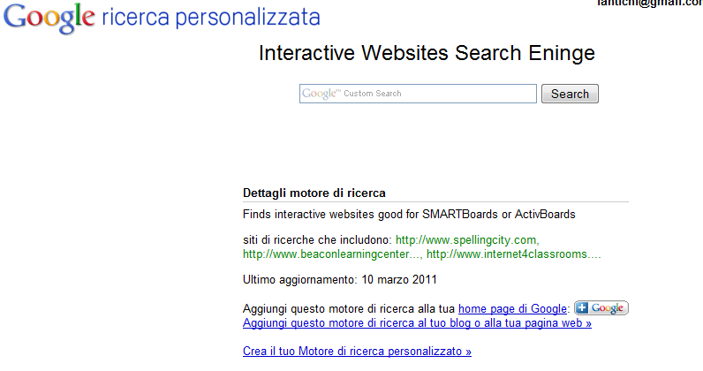
esempio:
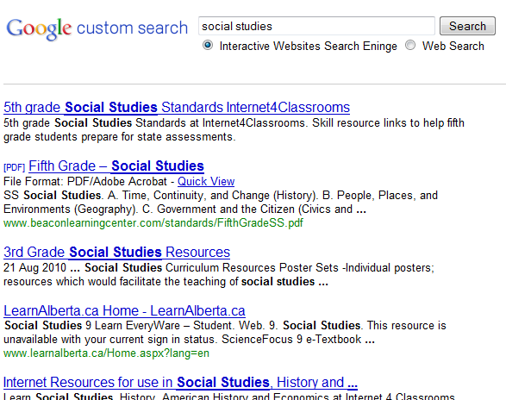

http://www.internet4classrooms.com/
http://copyrightconfusion.wikispaces.com/

http://www.theacropolismuseum.gr/default.php?pname=PeriodicExhibitions&la=2
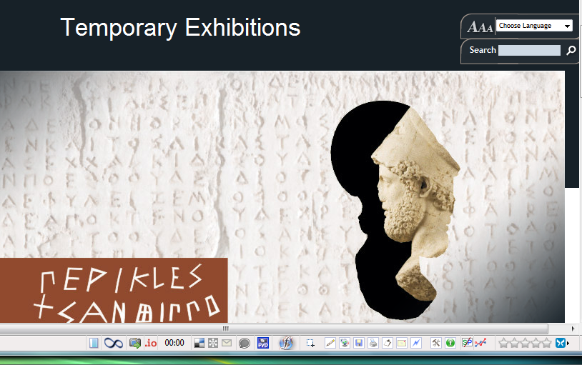

TOOLS
http://www.myavatareditor.com/
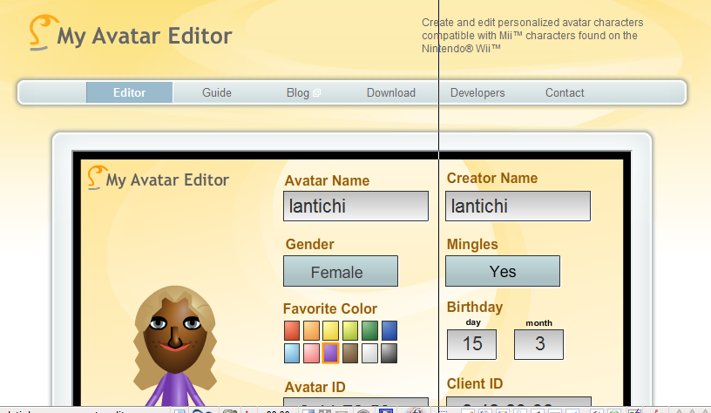

TUTORIAL SMART NOTEBOOK 10
http://www.youtube.com/watch?v=LuUKsOrCc7c&feature=related
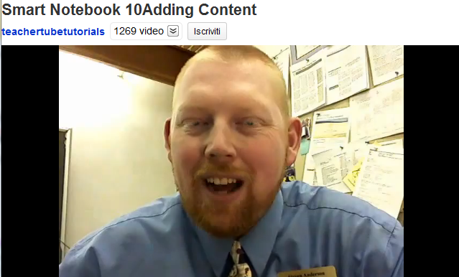

TUTORIALTABELLE
http://www.youtube.com/watch?v=UOyrzEyLnL8&feature=relmfu
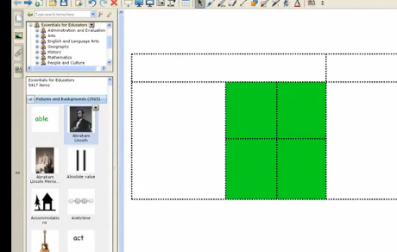

http://exchange.smarttech.com/search.html?subject=Letteratura

