<http://calibre-ebook.com/>

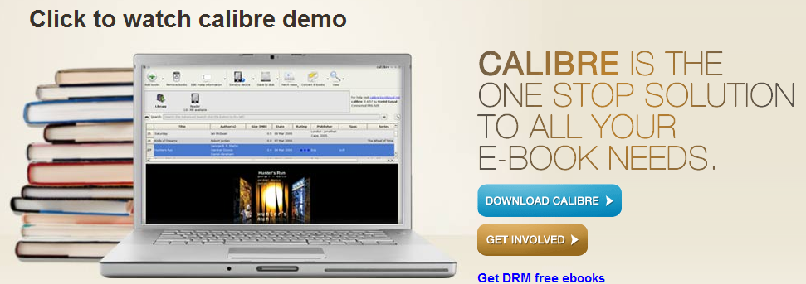

Manuale

chrome://epubreader/content/reader.xul?id=34

<http://manual.calibre-ebook.com/>